CLASS ACTIVITY CO3
Generate a code and execute for the following
1. Multiple catch statements
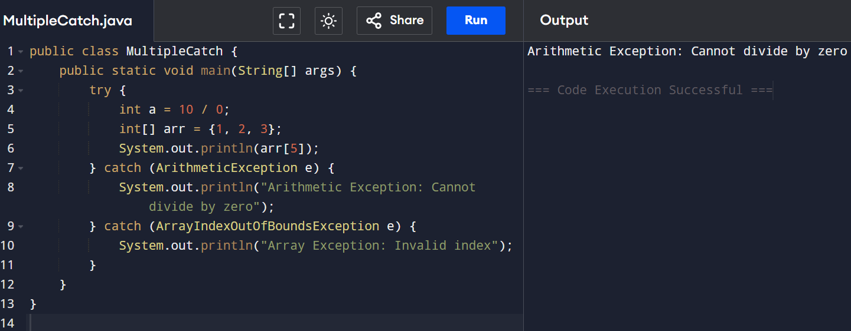
2. StringIndexOfBoundsException
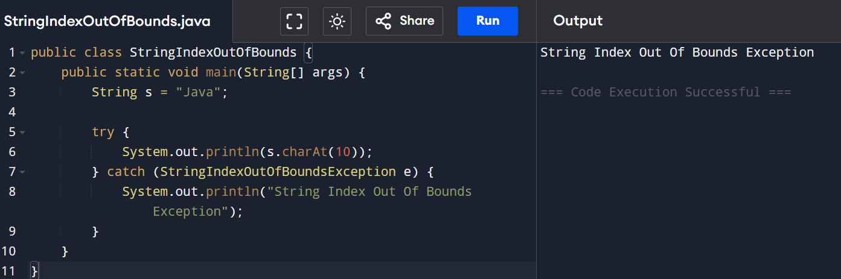
3. Finally
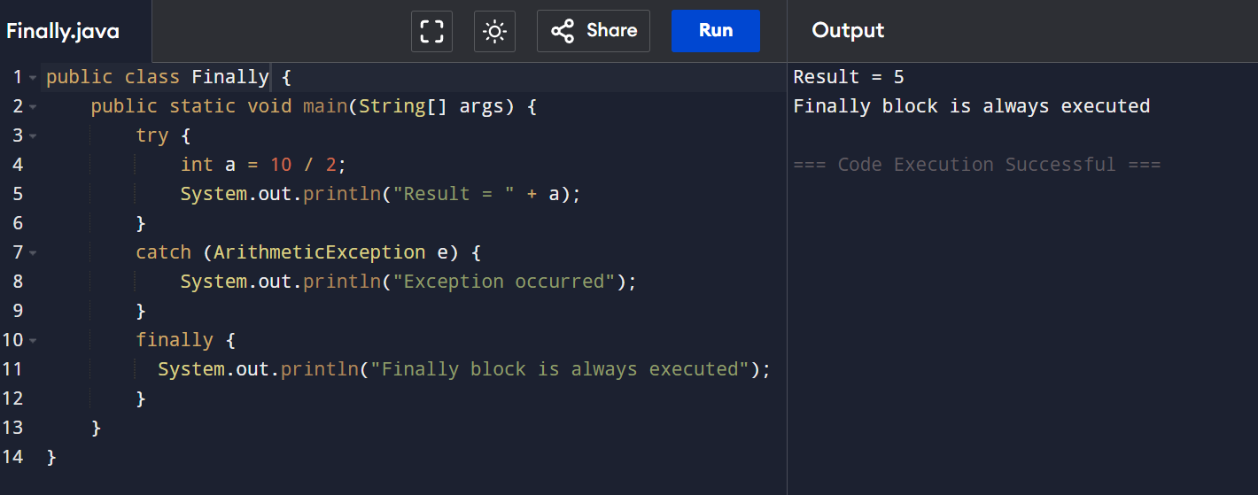
4. throw (to check person is eligible to poll the vote)
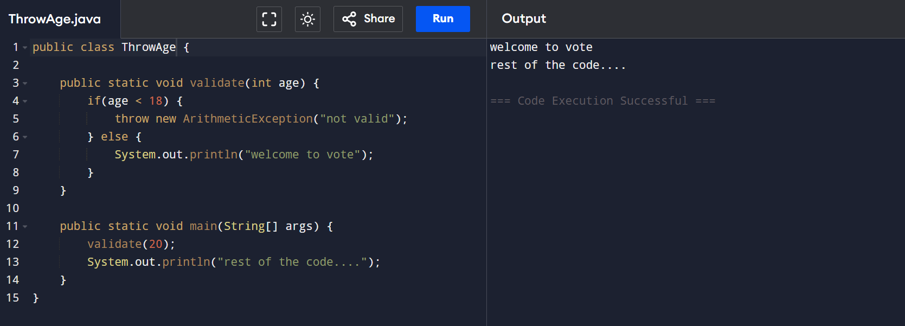
5. throws
